Architecture: Tiers/Layers model
The following Tiers/Layers model shows a high-level view of the webapp's architecture.
NOTE: later in the course more detailed diagrams will be required and your work done here will be migrated and managed within your team repository.
For this submission you are required to replace this diagram with your own rendition and update labels to accurately represent your system. Be sure to maintain the top-level order of the Tiers in the MVVM architecture but add representations of sample classes of your system and any other details you see fit.

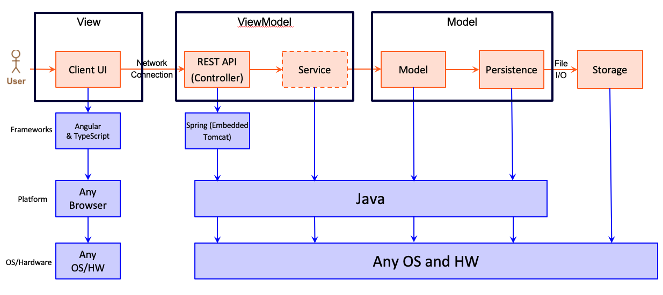
Describe you diagram and what Design principles you considered in support of your architecture.

